Strayer University

**Technical Project: Sample Website Project**

Week 10

for the

Course of

Web Design and Development

09/8/18

By

Kennedy Kabaso.

Professor: Rahat Zafar Ali

**Technical Paper.**

1. **Section 1: Narrative**

* **Create a narrative that describes the site to your prospective client.**

This paper is about the Car dealer ship website called Kennedy Car dealer. The company has hired me to build the Website that will link the site to external cars which will be sold to an internal one. Before I go any further, I would like to define Website. According to an article and I quote “Website is a location connected to the Internet that maintains one or more pages on the World Wide Web.”

In this assignment, I’m going to design a four-page site which will have a four separate cascade style sheet which are needed to do this whole site. Then link each of them to each page to make it easy to correct. Therefore, the details are as follows:

1. Website Pages.

* Home
* About Us.
* Gallery.
* Contact.

2. Cascade Style Sheets.

* mystyle.css.
* Mystyle2.css.
* mystyle3.css.
* mystyle4.css

Lastly, the home page will have some navigation menu which will link to other pages. It will have a heading which is very important to the visitor about the site. It will also have some images and some texts about the website.

The second pages will have the text about the specific of the site. It will have text and an image of the person who is the founder of the organization.

The third page will have a gallery of the cars which are for sale. It will give the visitor more cars.

The fourth page will have some contact information which give the visitor the chance to find the company.

**Section 2: Storyboard**

1. **Create a storyboard diagram depicting the layout of your Website.**

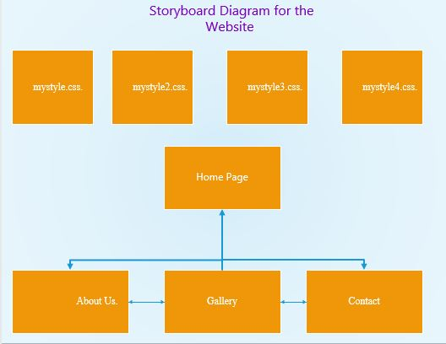

**Section 3: Business Website**

1. **screen shot of your emailed data from the guestbook.**

